Supplementary Information of “Composition and temperature-dependent phase transition in miscible Mo_{1-x}W_{x}Te₂ single crystals”
Yang-Yang Lv¹, Lin Cao¹, Xiao Li², Bin-Bin Zhang¹, Kang Wang², Bin Pang¹, Ligang Ma², Dajun Lin¹, Shu-Hua Yao^{1*}, Jian Zhou^{1*}, Y. B. Chen^{2*}, Song-Tao Dong³, Wenchao Liu^{1,4}, Ming-Hui Lu¹, Yulin Chen^{5,6} & Yan-Feng Chen^{1,7}

¹National Laboratory of Solid State Microstructures & Department of Materials Science and Engineering, Nanjing University, Nanjing 210093 China
²National Laboratory of Solid State Microstructures & Department of Physics, Nanjing University, Nanjing 210093 China
³Institute of materials Science and Engineering, Jiangsu University of Science and Technology, Zhenjiang 212003 China
⁴Institute of Advanced Materials (IAM) & Jiangsu National Synergetic Innovation Center for Advanced Materials (SICAM), Nanjing Tech University, Nanjing 211800 China
⁵School of Physical Science and Technology, Shanghai Tech University, Shanghai 200031, China.
⁶State Key Laboratory of Low Dimensional Quantum Physics, Collaborative Innovation Center of Quantum Matter and Department of Physics, Tsinghua University, Beijing 100084, China.
⁷Collaborative Innovation Center of Advanced Microstructure, Nanjing University, Nanjing, 210093 China

1. The lattice constant for MoTe₂ and WTe₂ of 2H, β and Td phase
Table I. Calculated and reported lattice (in the unit of Å) constant for MoTe₂ and WTe₂ of 2H, β and Td phase.
Structure | Calculated lattice constants | Reported lattice constants ^{[1]}
2H-MoTe₂ | a=b=3.530  c=14.068 | a=b=3.519  c=13.97
β-MoTe₂ | a=6.336  b=3.492  c=13.873  β=93º55’ | a=6.330  b=3.469  c=13.86  β=93º55’
Td-MoTe₂ | a=6.332  b=3.493  c=13.849 | a=6.33  b=3.469  c=13.83
2H-WTe₂ | a=b=3.530  c=14.112 | a=b=3.600  c=14.18
β-WTe₂ | a=6.285  b=3.491  c=14.238  β=94º3’ | N.A.
Td-WTe₂ | a=6.280  b=3.494  c=14.214 | a=6.282  b=3.496  c=14.07

2. The composition determinations of Mo_{1-x}W_{x}Te₂ single crystals
In the EDS measurements, we have collected the data in more than five different areas and taken the average value. During the quantitative calculations, the scattering cross sections of W, Mo and Te are calibrated by stoichometric WTe₂ and MoTe₂ powder and were taken in the all data analysis^{[1]}. All the EDS spectra of the as-grown Mo_{1-x}W_{x}Te₂ and β-MoTe₂ crystals are depicted in Fig. S1. The elemental compositions of all the crystal samples are shown in Table II. The ZAF factors of Mo-L, W-L and Te-L peaks are summarized in Table III.
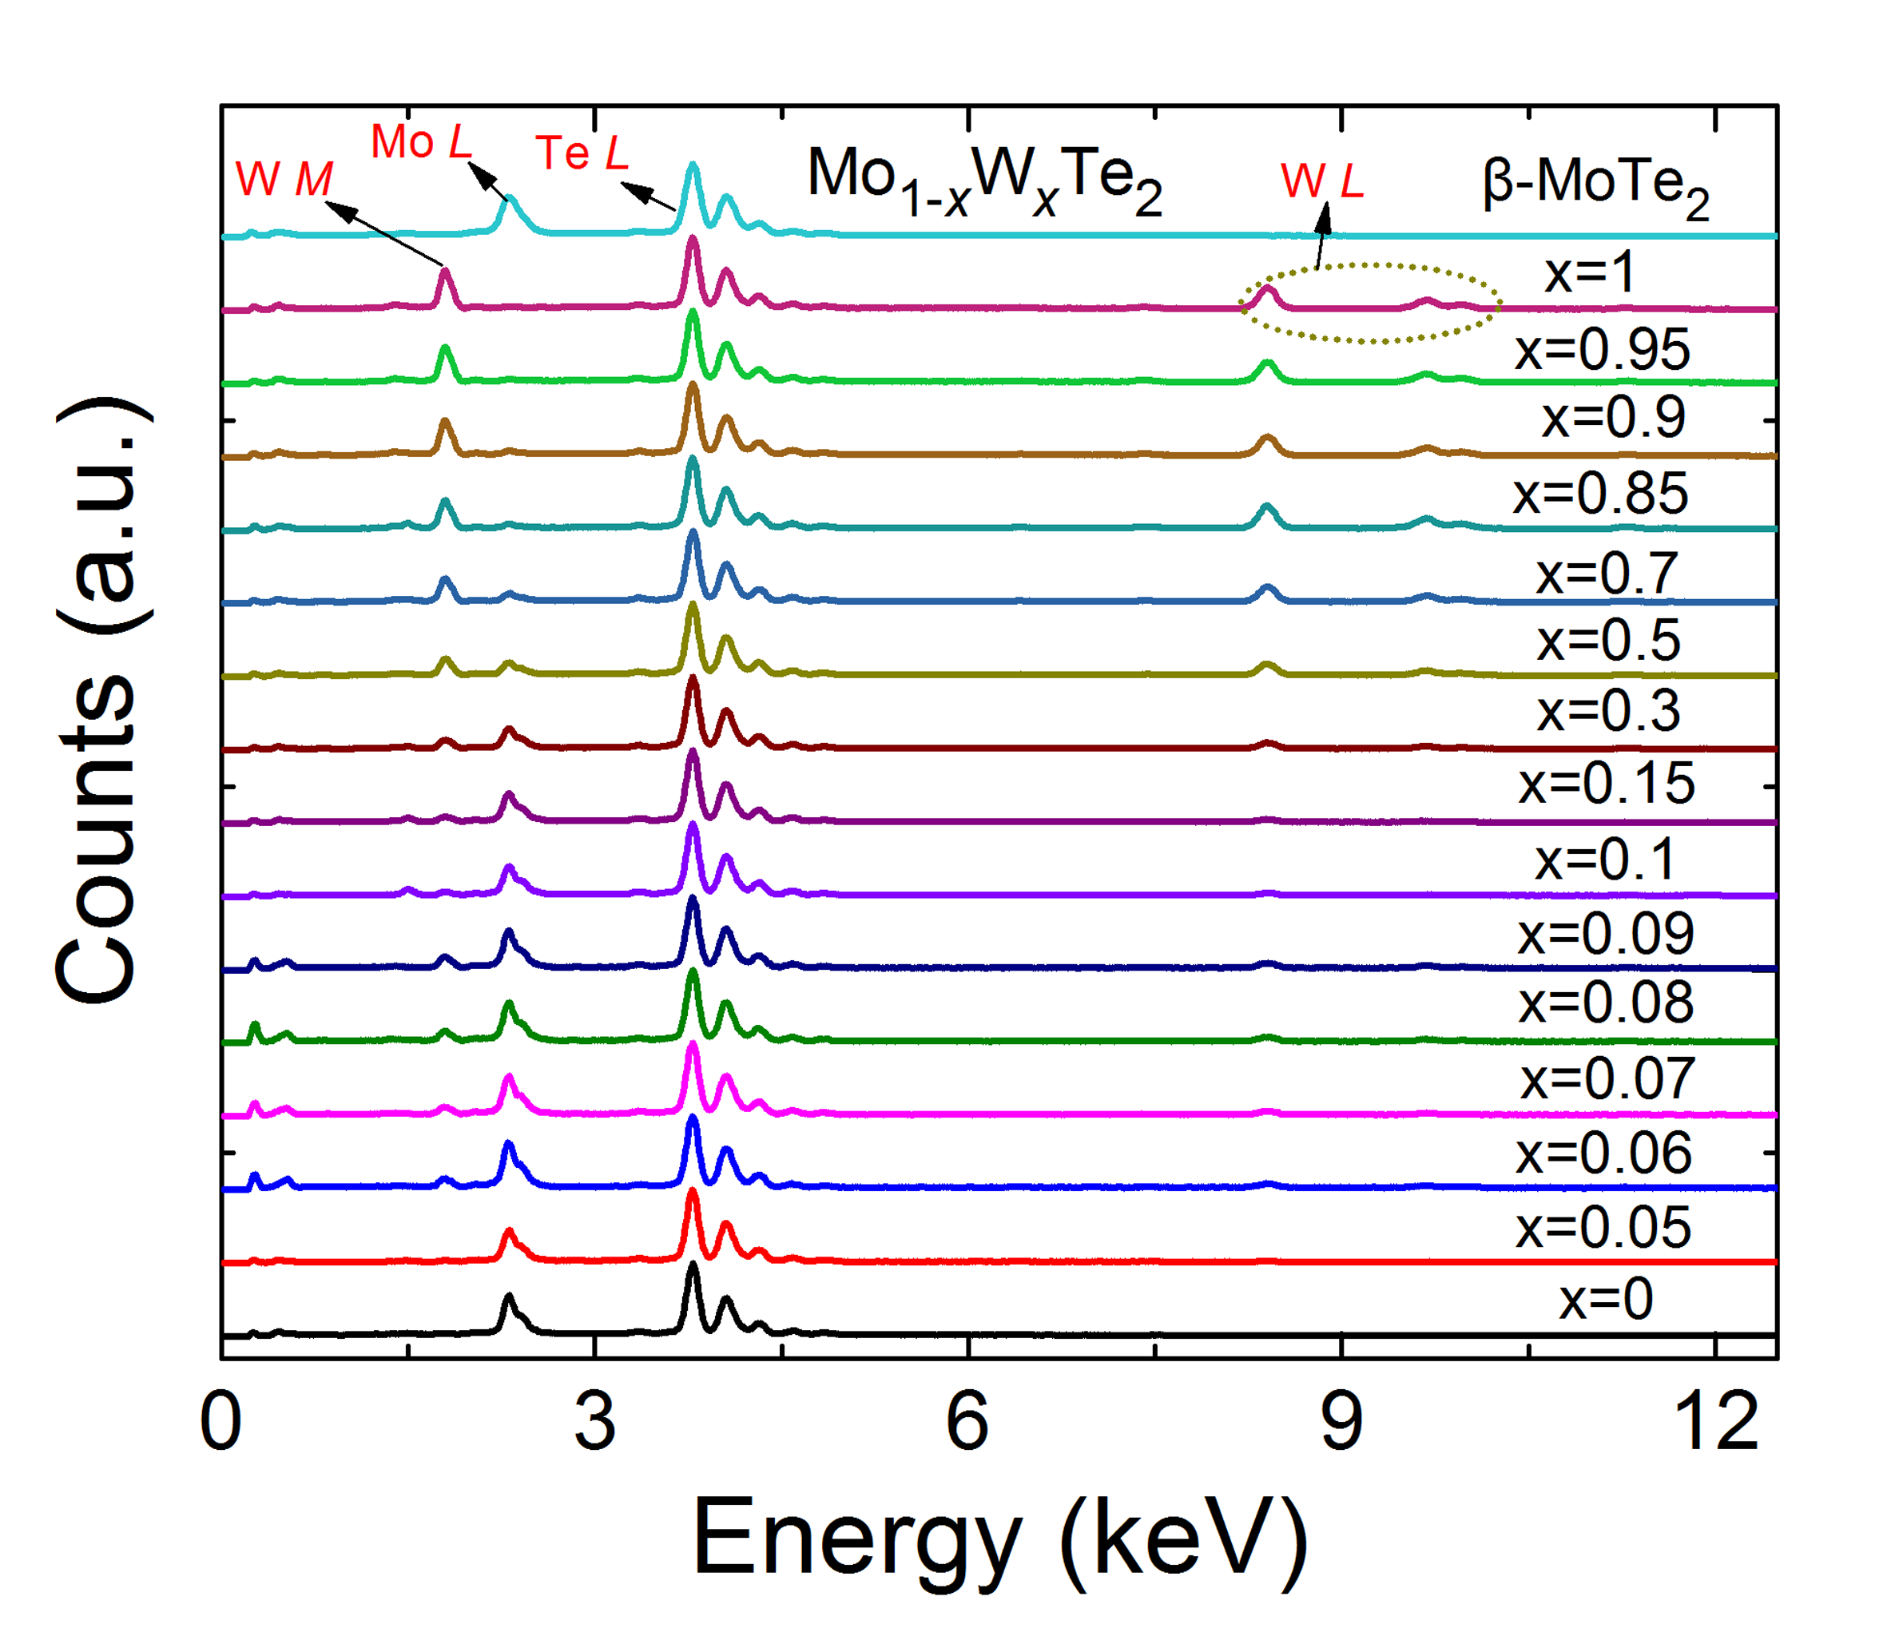
Figure S1. EDS spectra of the as-grown Mo_{1-x}W_{x}Te₂ and β-MoTe₂ crystals

Table II. The EDS experiment results of Mo_{1-x}W_{x}Te₂ and β-MoTe₂ crystals.
x | Mo (At%) | W (At%) | Te (At%)
β-MoTe₂ | 33.12 | 0 | 66.88
0 | 33.41 | 0 | 66.59
0.05 | 31.79 | 1.59 | 66.62
0.06 | 31.62 | 1.96 | 66.42
0.07 | 31.06 | 2.35 | 66.59
0.08 | 30.78 | 2.67 | 66.55
0.09 | 30.77 | 3.05 | 66.18
0.1 | 30.39 | 3.47 | 66.14
0.15 | 28.54 | 5.03 | 66.43
0.3 | 23.67 | 9.89 | 66.44
0.5 | 16.73 | 17.02 | 66.25
0.7 | 9.98 | 23.60 | 66.42
0.85 | 5.11 | 28.62 | 66.27
0.9 | 3.37 | 30.04 | 66.60
0.95 | 1.60 | 32.79 | 65.61
1 | 0 | 33.61 | 66.39

Table III. The cross section used in EDS analysis of Mo_{1-x}W_{x}Te₂.
 | Z | A | F
Mo-L | 1.0573 | 0.5404 | 1.0117
Te-L | 0.9881 | 0.8072 | 1.0000
W-L | 0.9702 | 0.9505 | 1.0000

3. The c-axis lattice parameter d_{c} of Mo_{1-x}W_{x}Te₂ single crystals
To show the effect of Mo substituted and non-stoichiometric on the lattice constant clearly, we plot the c-axis lattice parameter d_{c} for all Mo_{1-x}W_{x}Te₂ single crystals in Fig. S2. It can be seen clearly that there are three continuous change regimes (x=0~0.07, 0.10~0.50, and 0.70~1, respectively), which implies there may be three different phases. This may be due to the different lattice parameter c of 2H-MoTe₂, β-MoTe₂ and Td-WTe₂ (13.97, 13.86, and 14.07 Å, respectively)^{[2]}. But, by careful inspection, we find that from x=0.08 to 0.10 and from x=0.50 to 0.70, the d_{c} gradually decreases with increasing x (W composition). So it is reasonable to conclude that the phase transitions occur from x=0.08 to 0.1 and from x=0.50 to 0.70. Crystal structures of Mo_{1-x}W_{x}Te₂ compounds change from 2H, β to Td phase with increasing x.
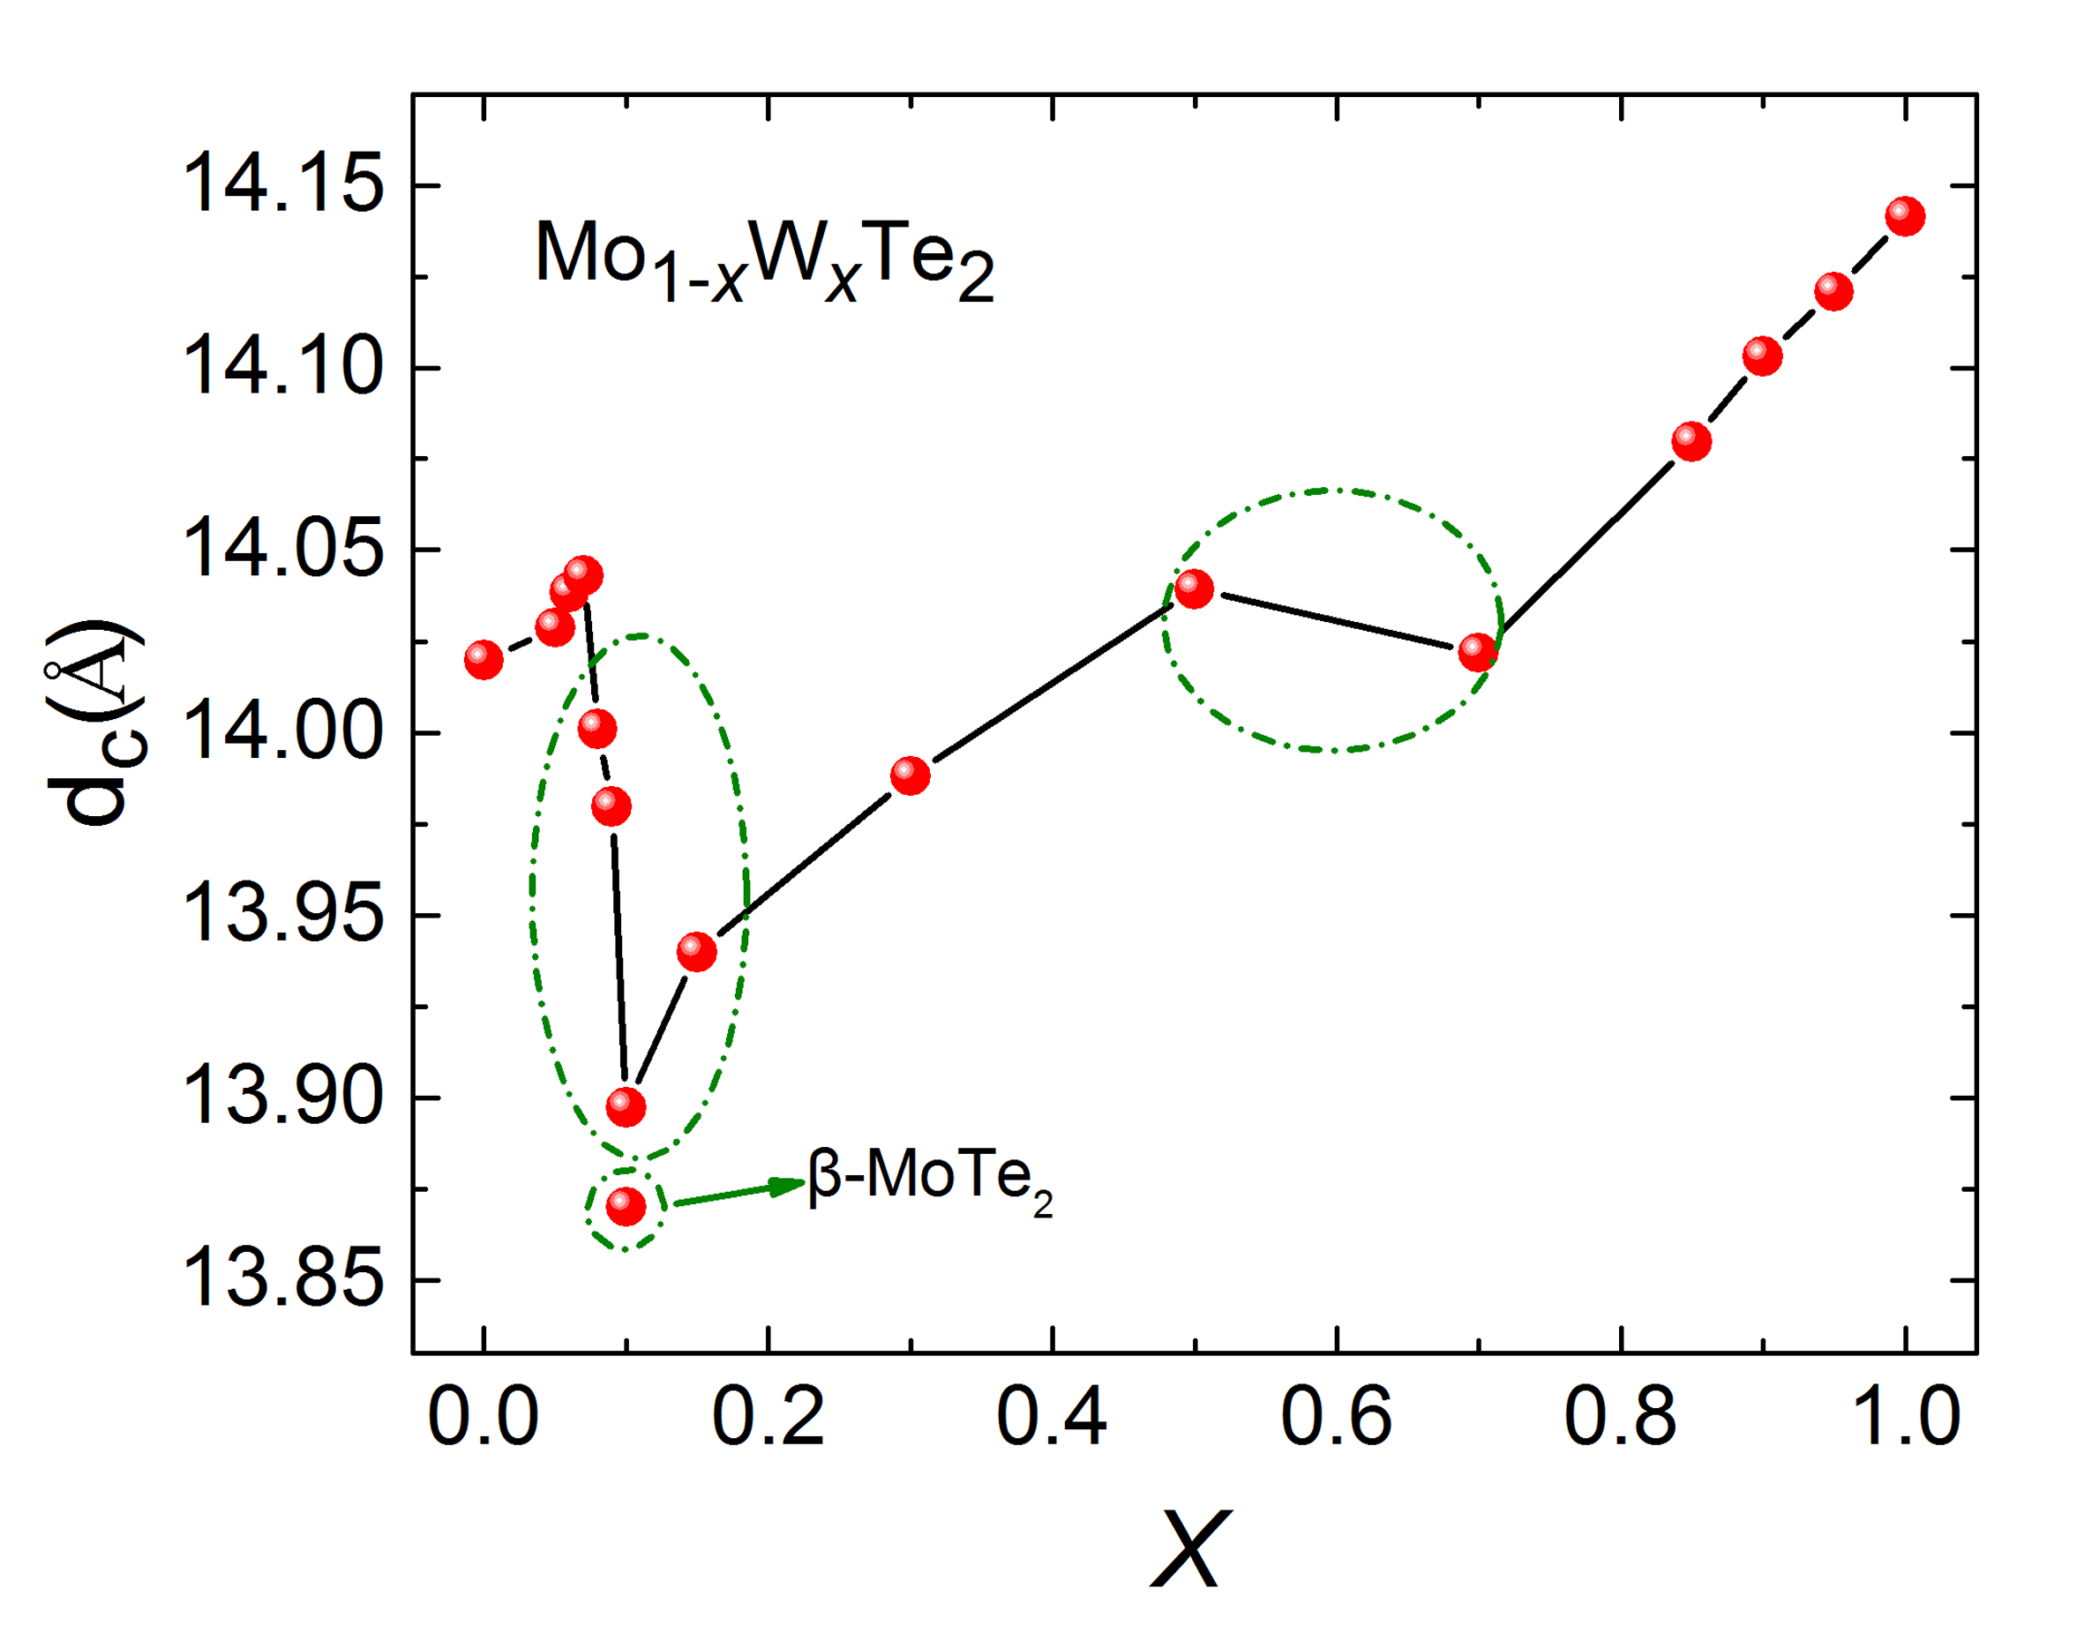
Figure S2. The c-axis lattice parameter d_{c} as a function of x for Mo_{1-x}W_{x}Te₂ system and β-MoTe₂, respectively.

4. The calculated and experimental Raman spectra for MoTe₂ and WTe₂ of 2H, β and Td phase

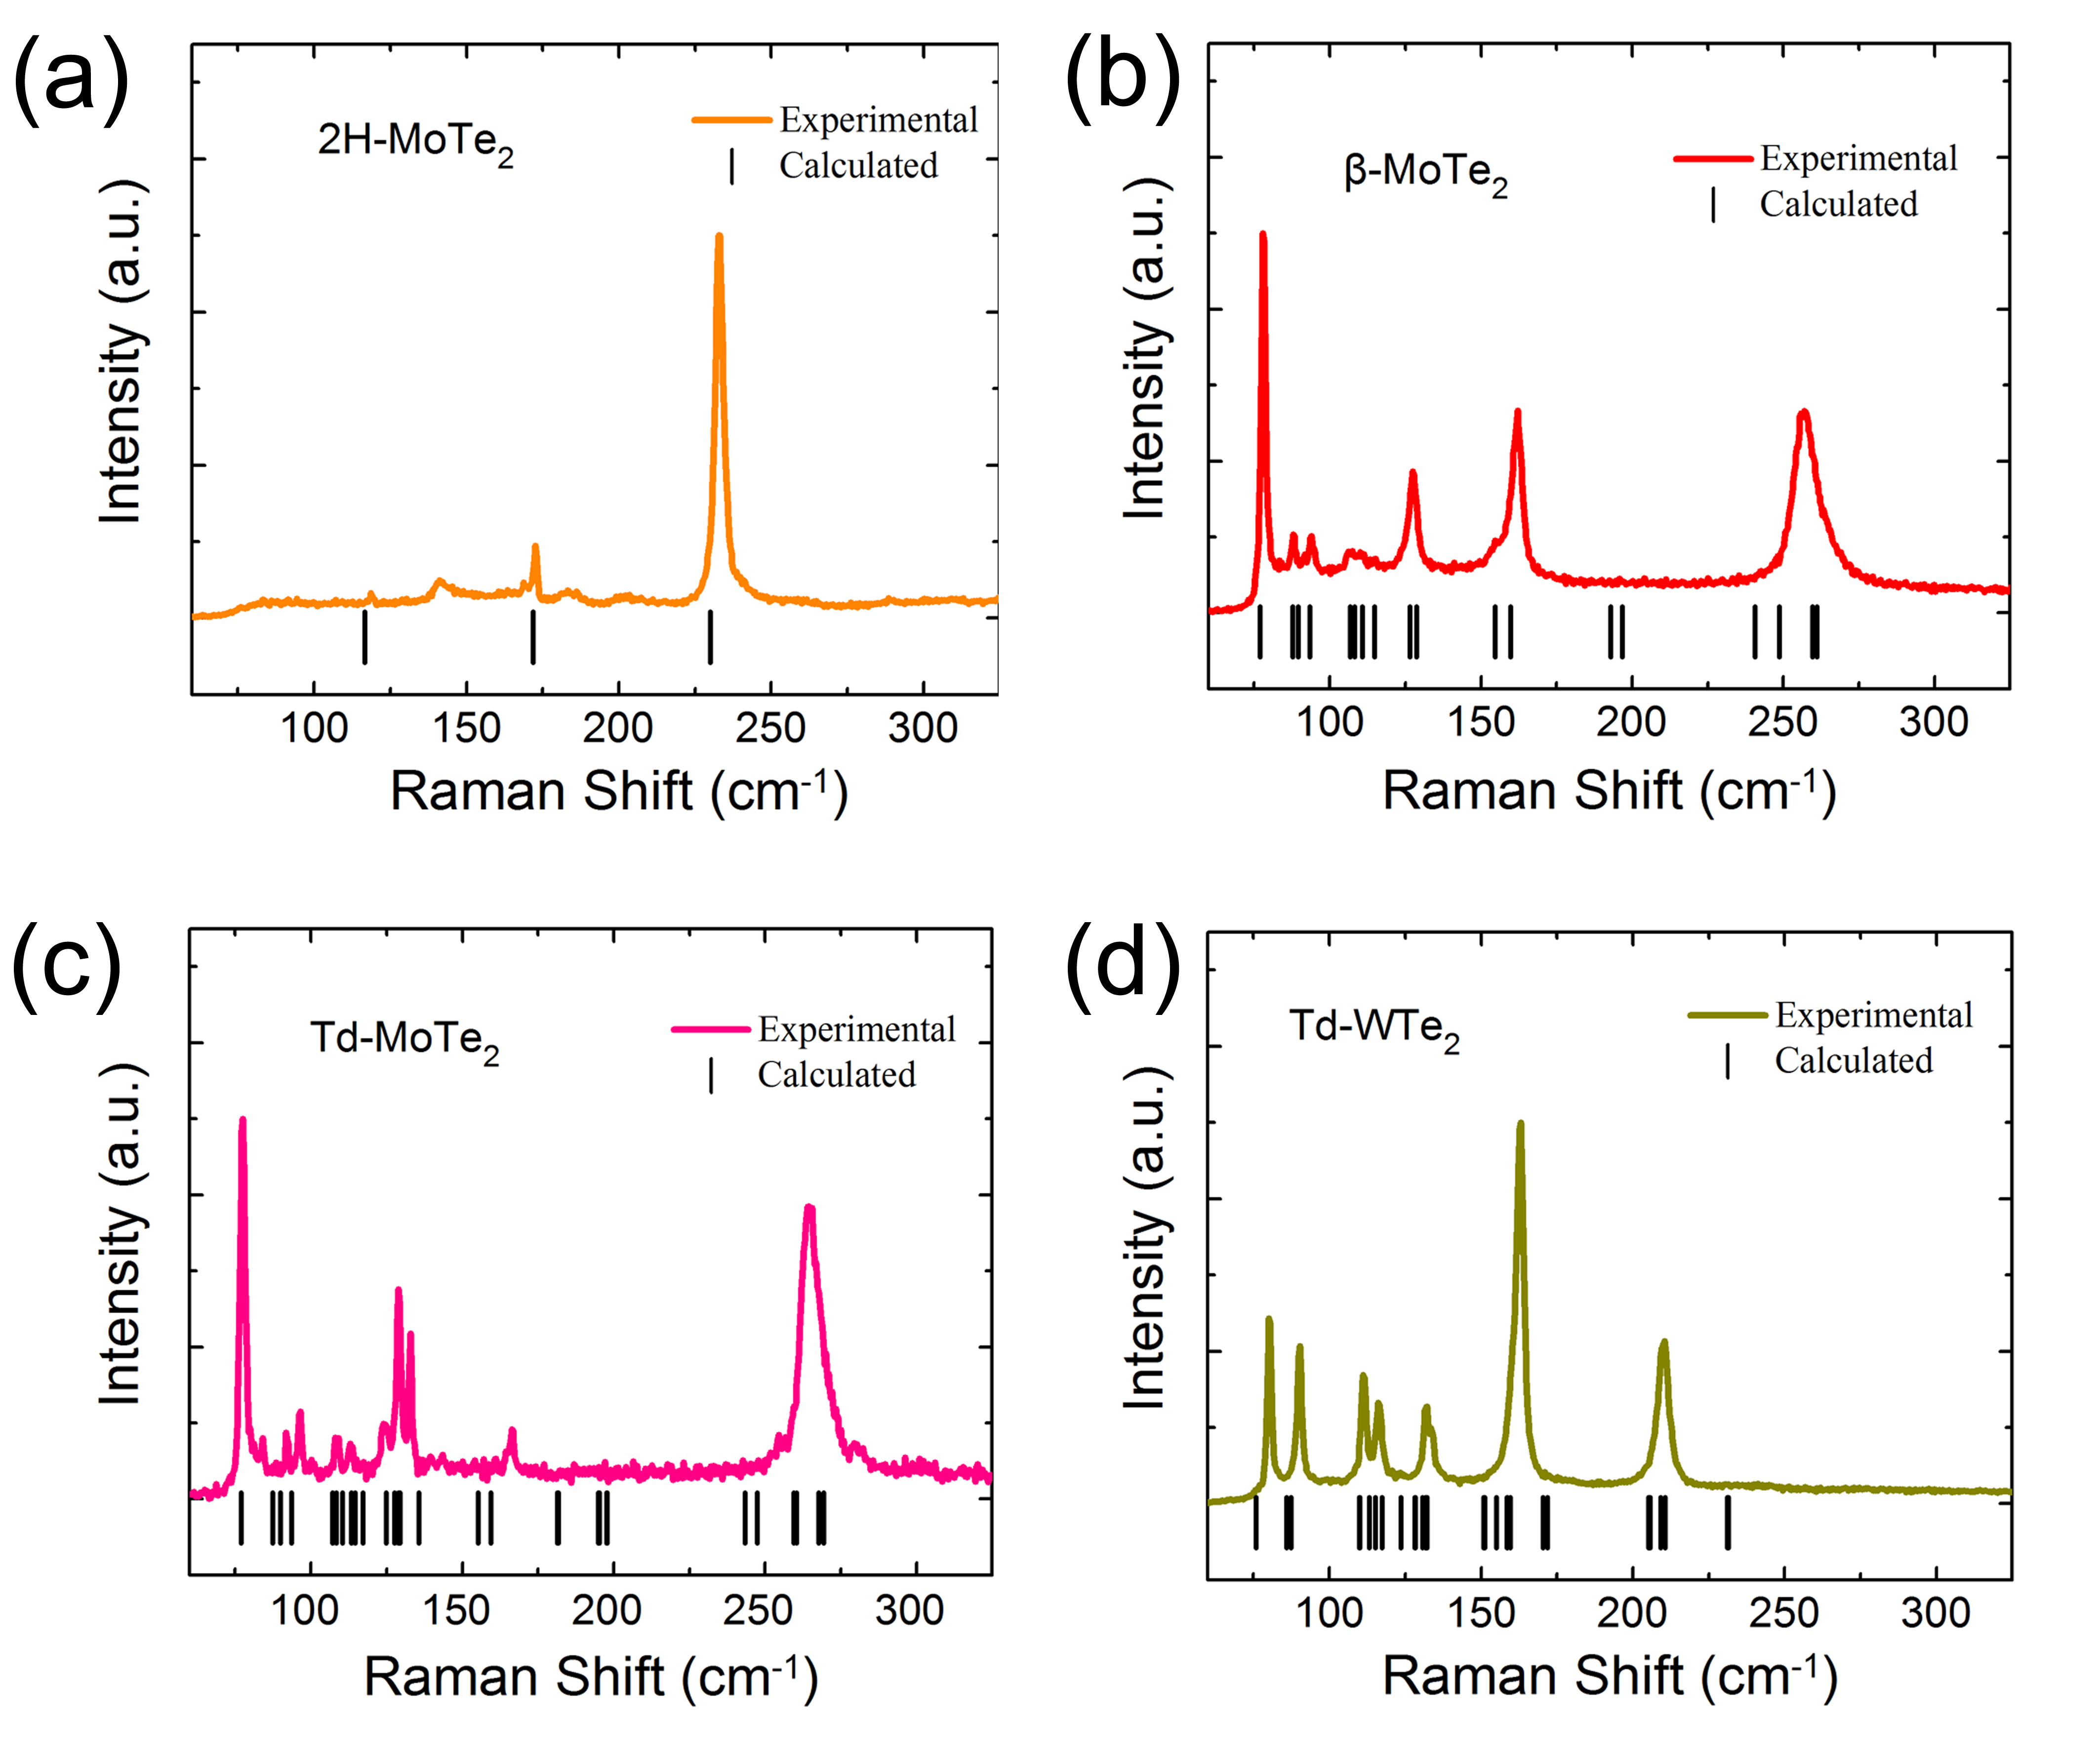
Figure S3. The calculated and experimental Raman spectra for MoTe₂ and WTe₂ of 2H, β and Td phase: (a) 2H-MoTe₂; (b) β-MoTe₂; (c) Td-MoTe₂; (d) Td-WTe₂.

5. The Raman spectra of Mo_{1-x}W_{x}Te₂ (x=0.3, 0.5 and 0.7) single crystals
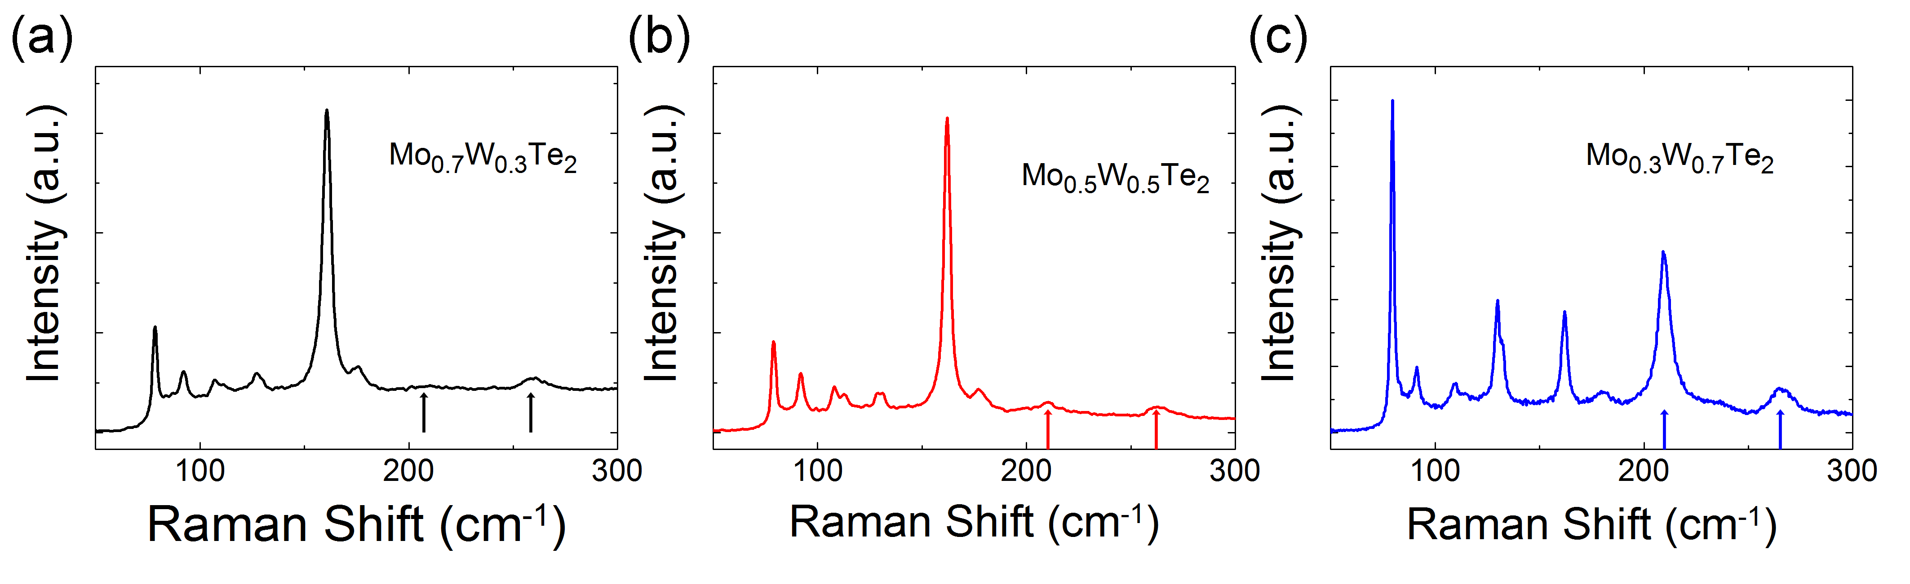
Figure S4. The Raman spectra of Mo_{0.7}W_{0.3}Te₂ (a), Mo_{0.5}W_{0.5}Te₂ (b) and Mo_{0.3}W_{0.7}Te₂ (c) crystals measured at room temperature.

6. The calculations of carrier concentrations and carrier mobilities for Mo_{1-x}W_{x}Te₂ and β-MoTe₂ single crystals
The Hall resistivities of Mo_{1-x}W_{x}Te₂ single crystals were measured by standard four-probe technique. According to the principle of Hall-effect measurements^{[3]}, the carrier concentrations can be expressed as
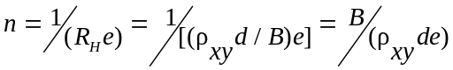 (1),
and the carrier mobilities can be expressed as
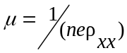 (2)
where n is carrier concentration, R_{H} is Hall coefficient, d is the thickness of the sample, B is the applied magnetic field, e is the charge of the electron, ρ_{xy} is Hall resistivity, μ is carrier mobility, ρ_{xx} is the electrical resistivity, respectively.

References
[1] Shindo, D. & Oikawa, T. Analytical Electron Microscopy for Materials Science (Springer-Verlag, Tokyo, 2002).
[2] Dawson, W. G. & Bullett, D. W. Electronic structure and crystallography of MoTe₂ and WTe₂. J. Phys. C: Solid State Phys. 20, 6159-6174 (1987).
[3] Putley, E. H. The hall effect and its applications. Contemp. Phys., 16, 101-126 (1975).

